Coding help for SPSS

Click on Analyze – Dimension Reduction – Factor

Bring the variables to be included in the factor analysis into the Variables Window:

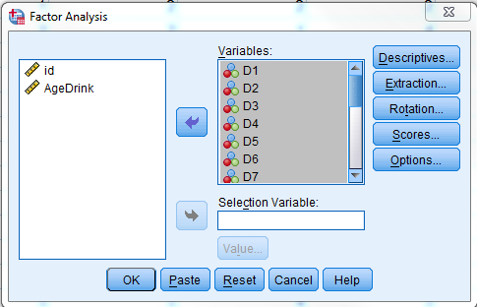

(You don’t need to do this step, but if you click on the ‘Extraction’ button, you will see that SPSS is using Principal components to identify factors, and using eigenvalues greater than 1.0 to identify the number of factors to keep:

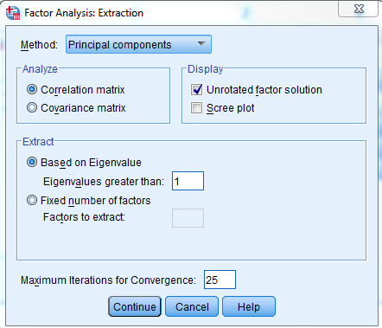

Click on the ‘Rotation’ button and click on ‘Varimax’. The ‘Rotated solution’ box will automatically be checked when you select Varimax:

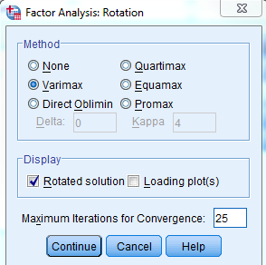

Click OK on the main factor analysis menu.

In the output, the ‘Extraction’ column under the Communalities table gives the communalities for the original variables. The ‘Total Variance Explained’ table gives the Eigenvalues for each of the principal components, and SPSS carries over the components with eigenvalues greater than 1.0 into the second (prior to rotation) and third (final factors after rotation) sets of columns in the table. I usually ignore the ‘Component Matrix’ which gives the factor loadings (correlations between the original variables and each of the principal components) for the components prior to rotation. To interpret the factors, I focus on the ‘Rotated Component Matrix’ which gives the correlations between the original variables and the final rotated components. I also ignore the ‘Component Transformation Matrix’, which is giving some behind-the-scenes information about the rotation.